FIELD REPORT
Introduction
- Punuluru HC III
- Location: Lira city, Punuluru
- Date of visit: 27th August 2026

1. General Observations
- The health facility is relatively new and was observed to be operational, with community members accessing services at the time of the visit. However, the number of patients seeking services remains relatively low compared to the facility’s capacity.
- The facility did not have a permanent signpost along the main road to guide clients to its location, as it is situated away from the roadside. The facility in-charge indicated that a signpost had been arranged and installed at the roadside on the morning of the verification visit to improve visibility and ease of access for clients.
2. Asset verification observations
The majority of the listed assets were physically located at the facility and were generally consistent with the provided records (inventory). The condition and functionality of the assets were also assessed during the visit.

Special note:
Asset register and verification documents
At the time of the verification visit, the facility’s asset register was not available for review and therefore could not be used as the primary reference for verifying the UGIFT-supported assets. The team instead relied on the inventory book that had been left by the previous facility in-charge, together with the knowledge of the staff member assigned to support the verification exercise. The staff member had been present when the UGIFT assets were delivered to the facility and was therefore able to provide information to guide the identification of the assets.
The team also sought supporting documentation from the District Headquarters. However, the District was only able to provide the relevant delivery note two days after the facility visit, by which time the physical verification exercise had already been completed. Consequently, the delivery note could not be used as a reference during the on-site verification.

The table below illustrates some physical status of the verified assets with photographic evidence.

PUNULURU HC III SIGN POST | 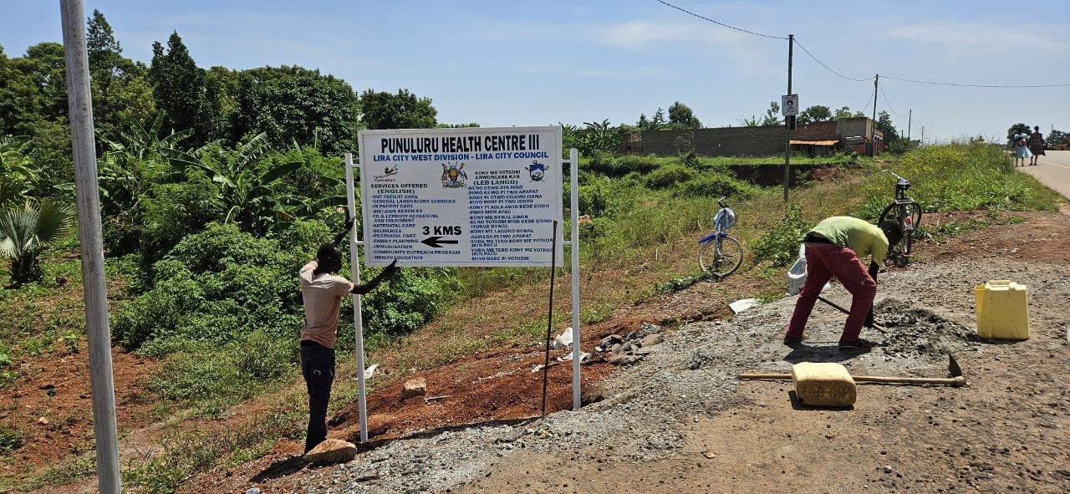
OUTPATIENT DEPARTMENT BUILDING | 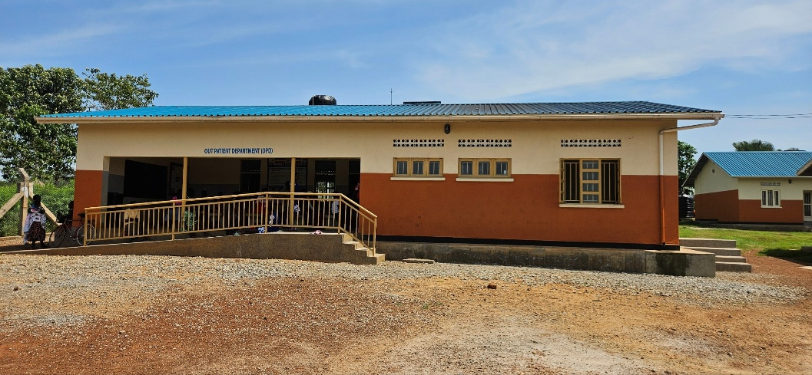
MATERNITY BLOCK | 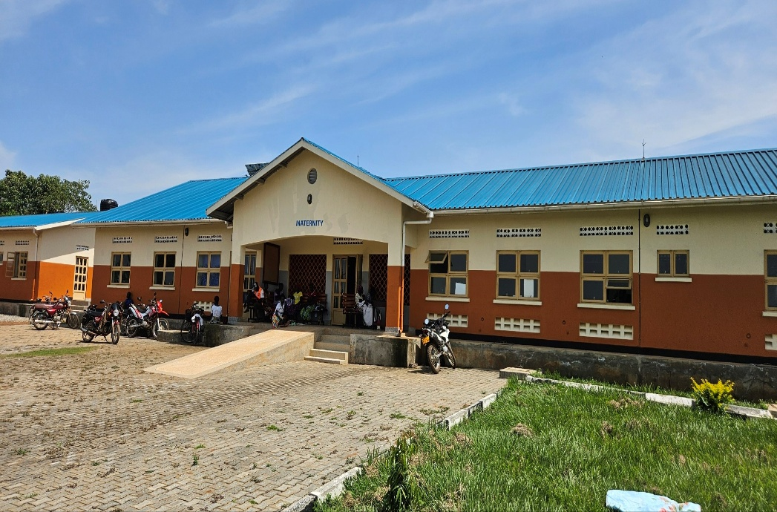
PUNULURU HC III (FRONT VIEW) | 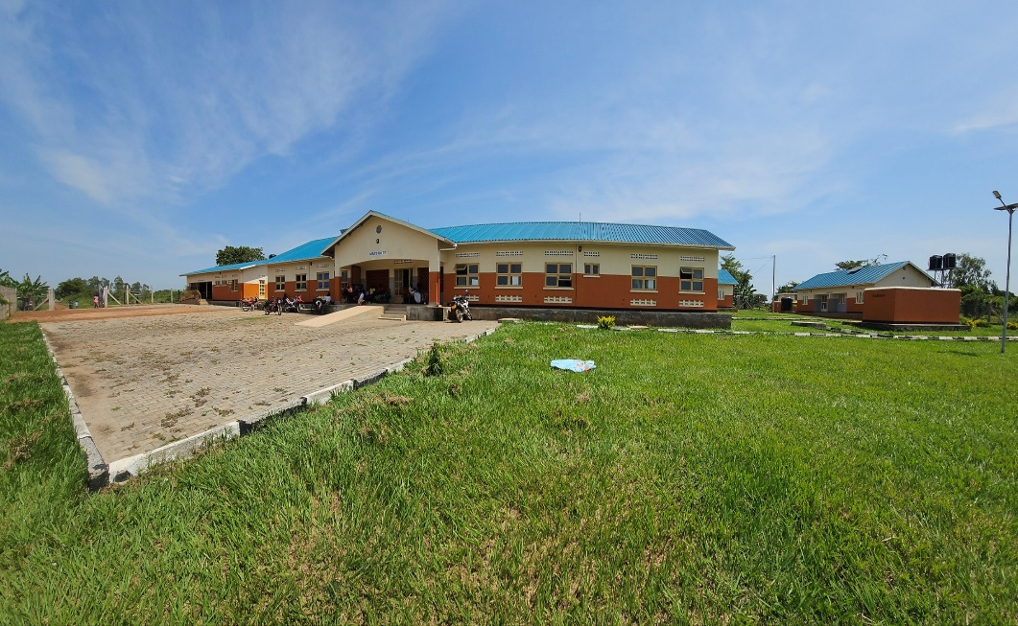
PUNULURU HC III (BACK VIEW) WITH WATER TANKS CONNECTED | 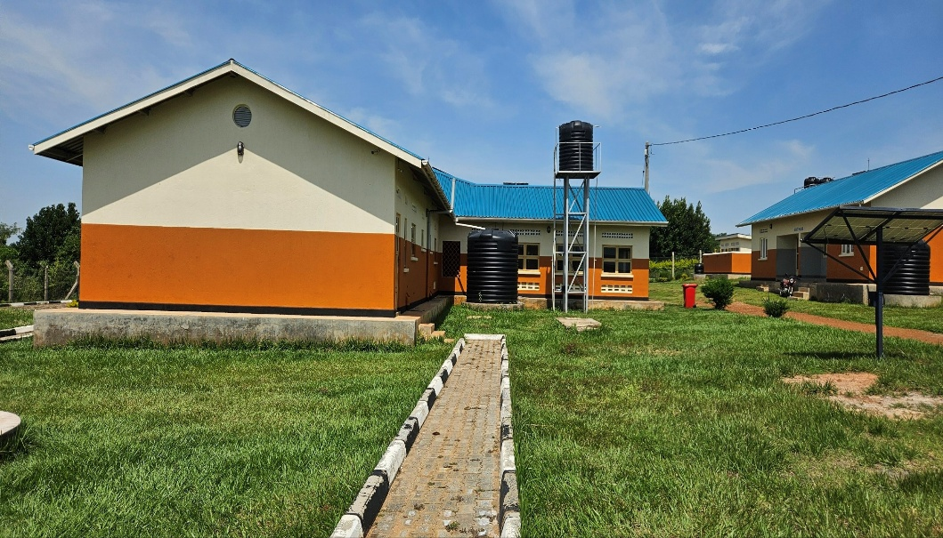
TYPICAL SET OF STAFF HOUSING (TWO UNITS AND TOILET BLOCK WITH A WATER TANK) | 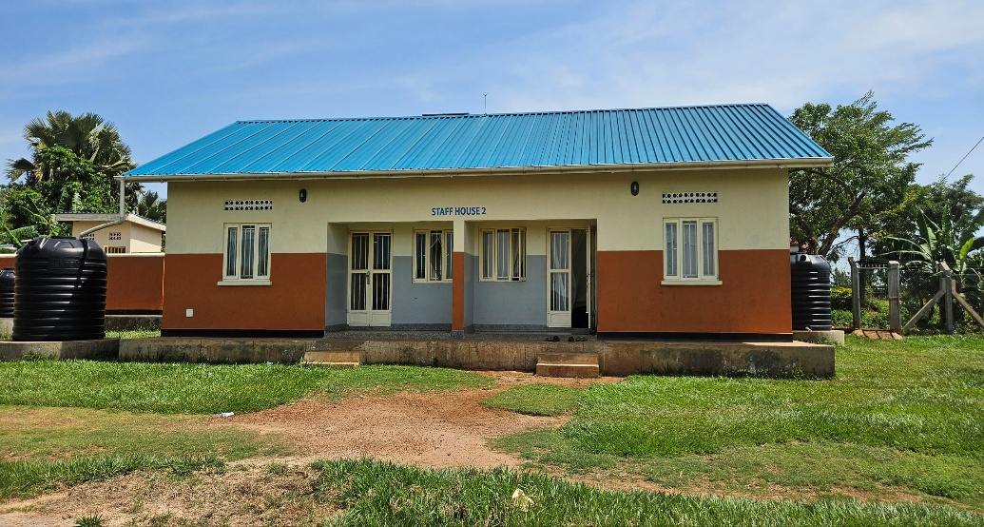
TYPICAL SET OF STAFF TOILETS (2 STANZAS PER UNIT) | 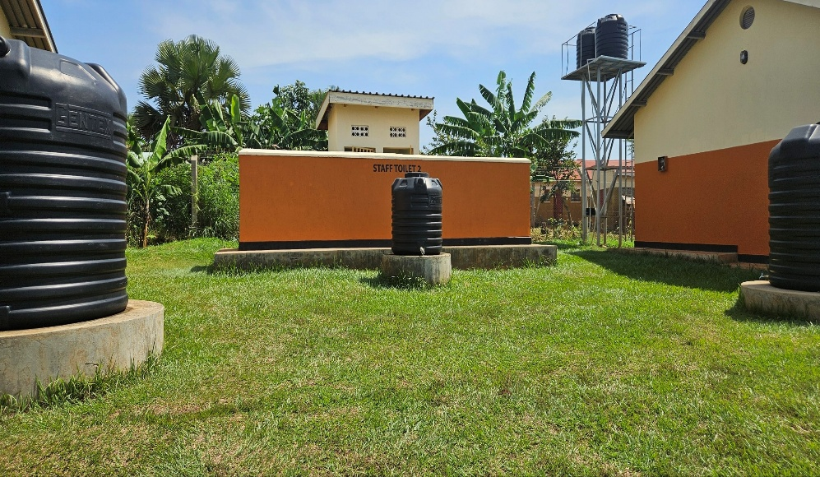
PLACENTA PIT | 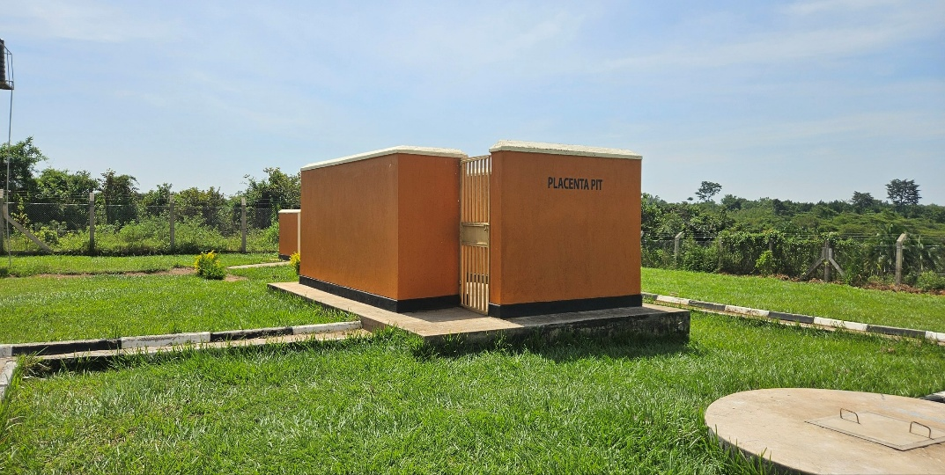
TYPICAL SET OF PATIENT TOILETS (4 STANZAS FOR MALE AND 4 STANZAS FOR FEMALES | 